**Kubernetes Task**

**Task Description:**

Setup minikube at your local and explore creating namespaces (Go through official documentation).

Explanation:

1. Visited the official website link : [minikube start | minikube](https://minikube.sigs.k8s.io/docs/start/?arch=%2Flinux%2Fx86-64%2Fstable%2Fbinary+download) to install minikube and chosen linux.

Command :

curl -LO https://github.com/kubernetes/minikube/releases/latest/download/minikube-linux-amd64

sudo install minikube-linux-amd64 /usr/local/bin/minikube && rm minikube-linux-amd64

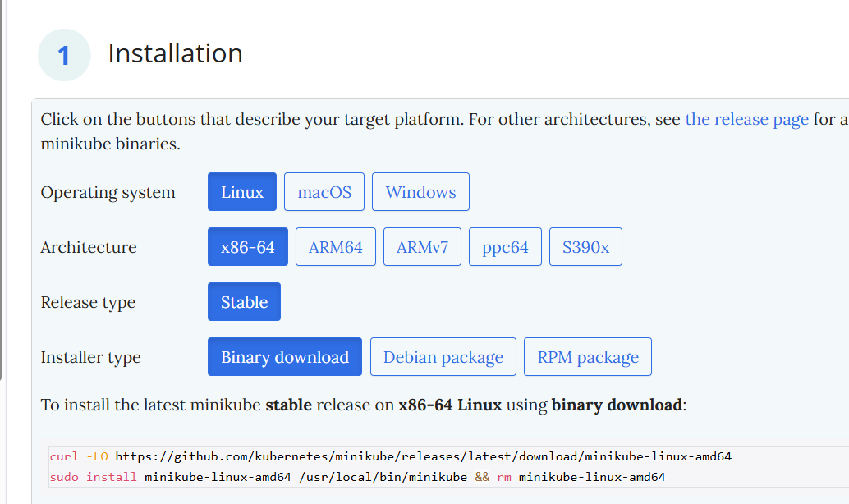

Entered the copied commands in the linux terminal (used vs code) 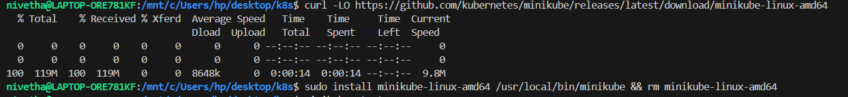

Opened docker desktop and kept running parallely.

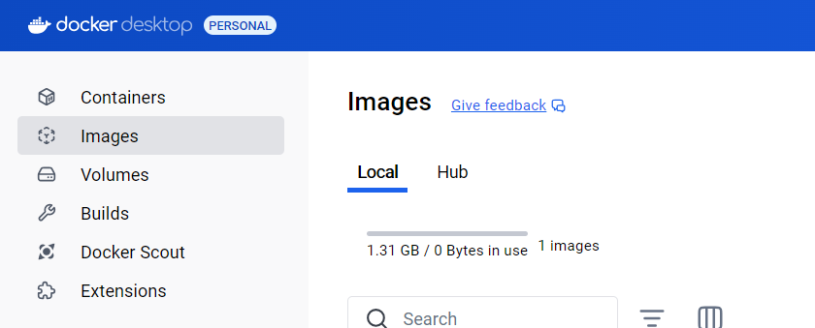

1. Used minikube start and minikube version to verify the installation.

minikube start

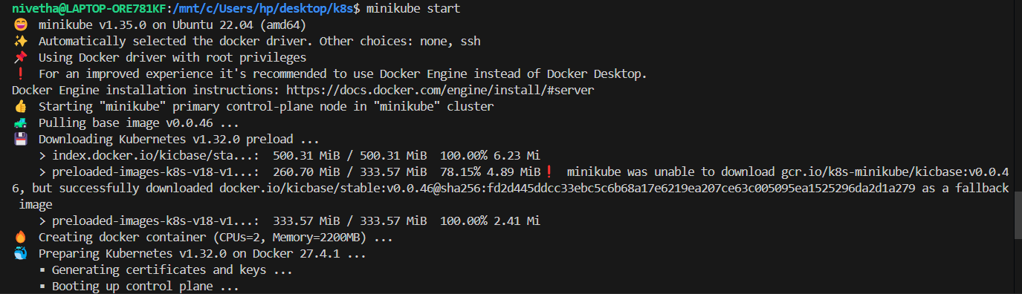

minikube version

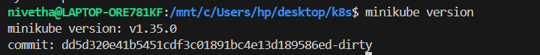

1. To install kubectl, visited the website link : [Install and Set Up kubectl on Windows | Kubernetes](https://kubernetes.io/docs/tasks/tools/install-kubectl-windows/) and copied the command :

curl.exe -LO "https://dl.k8s.io/release/v1.32.0/bin/windows/amd64/kubectl.exe"

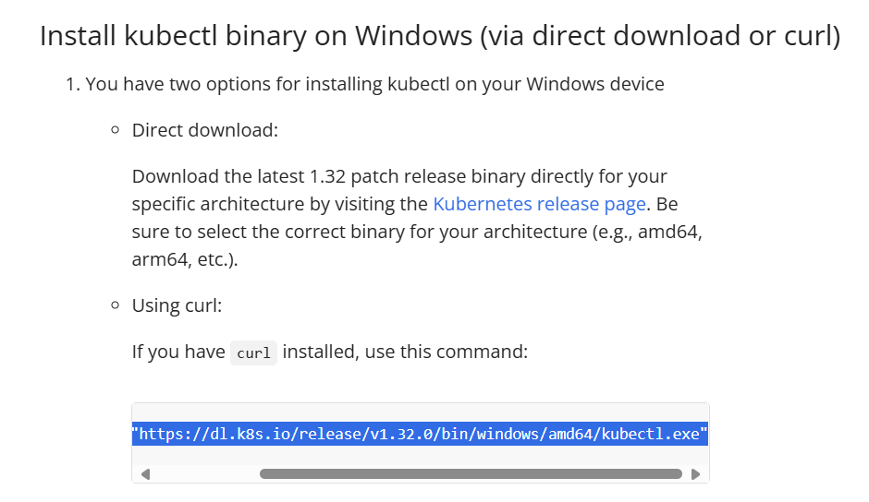

Entered the copied command in terminal



To verify installation, use kubectl version --client



1. Create namespace

In the terminal navigate to desktop and create folder k8s (mkdir k8s)

Use cd desktop

cd k8s

create file using vi say vi namespece.yaml



enter the following contents and press esc , :wq to save the contents.

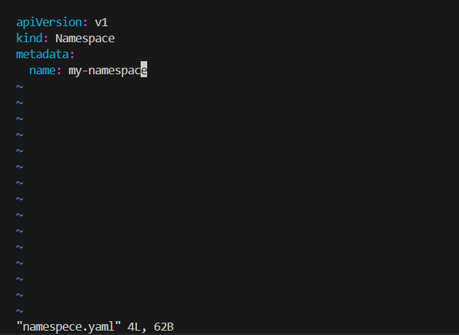

Use ls and cat to verify the contents.

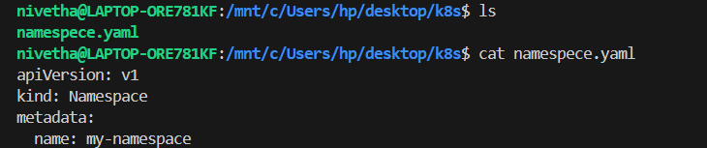

1. Apply the yaml file using

kubectl apply -f namespece.yaml



List namespaces using kubectl get namespace

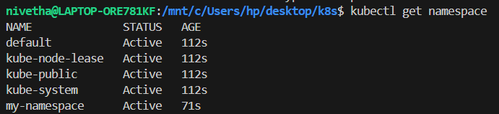

To work within specific namespace, use

kubectl config set-context --current --namespace=my-namespace



To delete the namespace, use kubectl delete namespace my-namespace

